Tangible Elements, Intangible Services: A Multidimensional Literature Review of Bookstore User Experience

Tangible Aspect Research
In Chinese context, due to the significant impact of e-commerce and the improvement of citizen life, several papers analyzing the bookstores through a physical setting lens appeared in the recent years, aiming at a better redevelopment and the role transition of bookstores. For example, following a conventional environment-behaviors study style, Zhang et al. (2021) analyze a specific bookstore in Dalian from a tangible perspective, with observation mappings and customer flow drawings. With a problem-oriented approach, the study offers targeted recommendations derived from a detailed physical‑space analysis of the bookstore, including flexible facility arrangements, and parent-child zone designs.
More specifically, some relevant papers focused on detailed physical aspects of similar environments of bookstores. Recent research (Cui & Ahn, 2025) delved into the light settings of university libraries, featuring “poor lighting design—particularly issues such as uneven illuminance, excessive glare, and inefficient use of natural light”, and raised a new design methodology for lighting in book-reading area by NSGA-II optimization, considering multiple factors, including energy saving, comfort and effectiveness, while another research about general retail environments (Suresh et al., 2025), highlights that “a crucial determinant of consumer happiness is the shop layout, which impacts customers' navigation, exploration, and interaction with merchandise”, and also raised a new retail area design concept of adaptive layout by reinforcement learning. Together, these studies demonstrate how detailed physical design parameters—ranging from lighting systems to spatial configuration—shape user experience in meaningful and interrelated ways, which can be promoted into bookstore analysis and improvements.
Intangible Aspect Research
Meanwhile, other researchers featured intangible elements in bookstore. Across recent work on bookstore marketing strategy, scholars mainly discussed a shift from survival tactics to value reinvention. A study of Pioneer Bookstore (Wang, 2025), suggests four major optimizations from the dimension of customer perceived value: “the strengthening of spatial emotional value, the extension of the value of knowledge services, the construction of the value of community belonging, and the cultivation of the value of cultural identity”, so that the offline visit becomes an irreplaceable experience. Complementing this micro, experience-centric view, a 4V strategy study (An, 2020) uses VAR modeling to link bookstore revenues to macro demand drivers, such as digital reading rates, national publications, public libraries to highlight the issue of role transition and value reinvention from another perspective, urging operators to recalibrate positioning and offerings, in order to differentiate against digital substitutes. Taken together, the current literature suggests a strategy reconsider of value reinvention and reinforcement for better user experience in the internet era.
Another crucial intangible element affecting user experience besides marketing strategy is the service quality. In terms of this, a study (Addis, 2016) adapts an innovative research method by analyzing the customer journey in bookstores to reflect the bookstore service quality and more importantly the user experience. “It proposes that customer experience can be deeply understood only via a broad research design involving several different profiles of participants, that are managers and booksellers, customers of different familiarity with bookshops” (Addis, 2016), in the end it offers new insights from different customer groups and manage to better design the process for the managers to map customer journey.
The Need for Comprehensive Research
While there have been multiple research projects featuring bookstores and associated user experiences, relatively few of them approach the topic with a comprehensive scope considering both the tangible aspects of the physical setting, including seats, lights setting and overall spatial arrangement, and the intangible dimensions of marketing, service quality and atmosphere. Much of the existing literature on bookstores addresses either tangible environmental elements or intangible experiential aspects in isolation, with limited attention to how these dimensions interact organically. This single-dimensional focus may constrain the breadth of insights into how bookstores shape user experience and limit the potential improvements of bookstores accordingly.
The Need for Bookstore-Featured Analysis
When it comes to service quality, as a popular topic in traditional economy and commerce, much research outside bookstore context can be referred to. Research (Brady & Cronin, 2001) defines the three dimensions of service quality, including interaction, environment, and outcome, and further explained them into 9 subdimensions with a hierarchy approach (Fig 1), from which the interaction section can be seen as the main intangible part reflecting service quality. Besides this overall definition, a study (Wolter et al, 2019), featuring more specifically the correlation between customer satisfaction and employee satisfaction and the repatronage intention, explores this service quality pattern further by analyzing real life examples happening in retail industry.
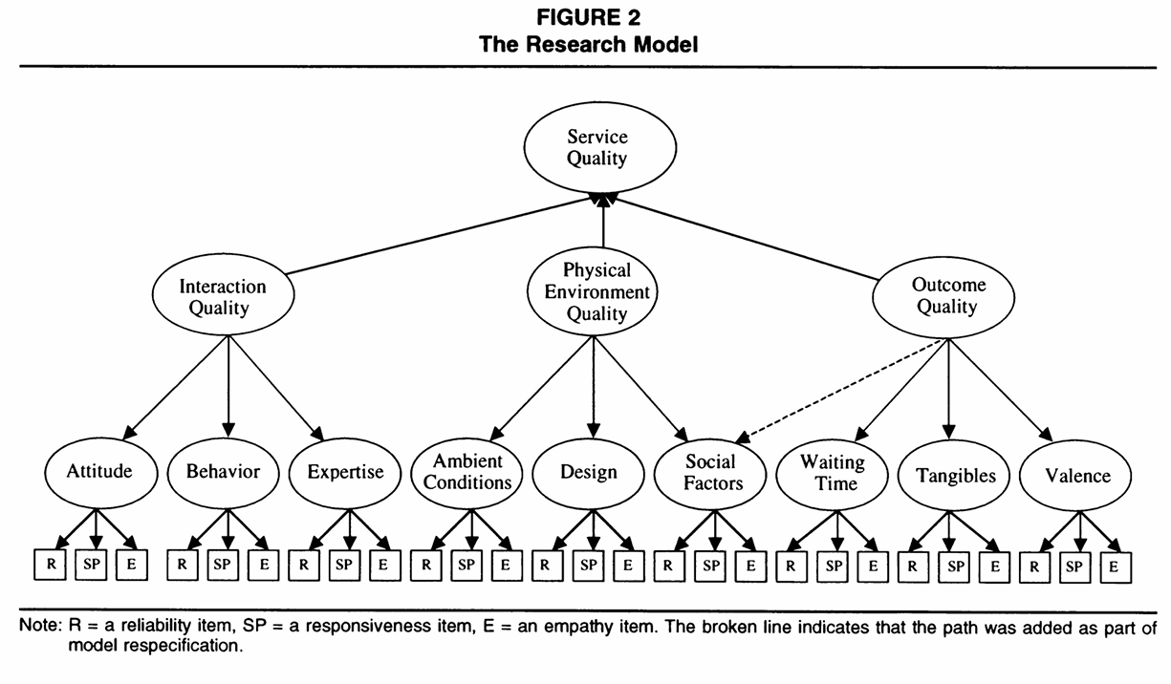
Fig 1. Research Model (Brady & Cronin, 2001)
However, as Addis (2016) pointed out, “Bookshops are much more than retailers aiming at distributing books. They offer an entire social platform that especially curious individuals are willing to explore. These benefits represent potentially relevant drivers for bookshops positioning, defining the framework for their customer experience concept.” This highlights cultural and social characteristics far beyond book retailing. Bookstores nowadays acting more as “third places” that facilitate communicating, gathering, and meaning‑making. Thus, it distinguishes bookstores from other retail environments and underscores the special need to understand how service quality—particularly in such a hybrid cultural–commercial setting—shapes user experience.
The Need for Hong Kong-Based Conclusion
Much of the studies demonstrate geographical characteristics and site-specific orientation, such as bookstores in Rome in Addis’ study (2016), and Pioneer Bookstore in Wang’s (2025). While this sharpens the practical relevance of their findings for local contexts, they also limit the generalizability of conclusions across settings. Against this backdrop, Hong Kong stands out as a context that differs markedly from many cited cases. First, given Hong Kong’s exceptionally high population density alongside a sizable older‑adult population, bookstores tend to operate within more constrained physical footprints while serving larger and more age‑diverse user bases. Second, as a city of cultural exchange—home to residents from multiple cultural backgrounds, layered with substantial tourist flows—the cultural functions of Hong Kong bookstores are often more salient: the reinvention and reinforcement of cultural value become more urgent and more opportunity‑rich than in cited regions. Taken together, these features underscore the distinctiveness of Hong Kong’s bookstore ecology and point to the need for literature that addresses Hong Kong on its own terms rather than extrapolating from other regions—precisely the gap that the present study seeks to address.

References
Addis, M. (2016). Understanding the customer journey to create excellent customer experiences in bookshops. International Journal of Marketing Studies, 8(4), 20–36. http://dx.doi.org/10.5539/ijms.v8n4p20
An, Q. (2020). Research on 4V marketing strategy of physical bookstore based on consumer behavior. Proceedings of the 1st Africa‑Asia Dialogue Network (AADN), Advances in Social Science, Education and Humanities Research, 476, 45–50. Atlantis Press. https://www.atlantis-press.com/proceedings/aadnic-19/125944945
Brady, M. K., & Cronin, J. J. (2001). Some New Thoughts on Conceptualizing Perceived Service Quality: A Hierarchical Approach. Journal of Marketing, 65(3), 34–49. http://www.jstor.org/stable/3203465
Cui, X., & Ahn, C.-W. (2025). Multi-Objective Optimization of Natural Lighting Design in Reading Areas of Higher Education Libraries. Buildings, 15(9), 1560. https://doi.org/10.3390/buildings15091560
Suresh, P., Sivakumar, T., Revathy, N., & Pandi, M. (2025). Enhancing customer experience in retail for adaptive store layouts with reinforcement learning. International Conference on Visual Analytics and Data Visualization. 69–74. IEEE. https://doi.org/10.1109/ICVADV63329.2025.10960948
Wang, C. (2025). Study on marketing strategies of physical bookstores based on customers’ perceived value. Academic Journal of Management and Social Sciences, 10(3), 29–31.
Wolter, J. S., Bock, D., Mackey, J., Xu, P., & Smith, J. S. (2019). Employee satisfaction trajectories and their effect on customer satisfaction and repatronage intentions. Journal of the Academy of Marketing Science, 47(5), 815–836. https://doi.org/10.1007/s11747-019-00655-9
Zhang, Y., Zhou, B., Sun, Y., & Zhao, Y. (2021). Research on space design of physical bookstores based on customer behavior. Urbanism and Architecture, 18, 139-144.

